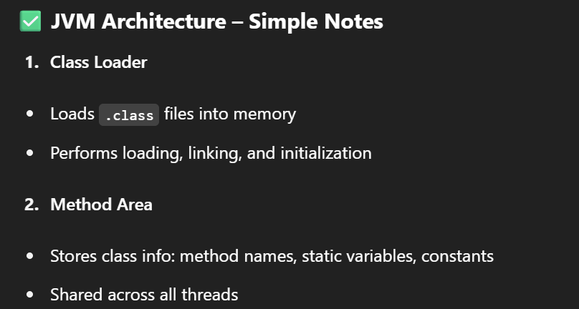

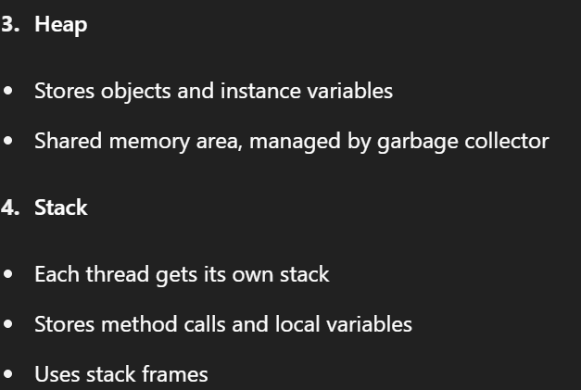

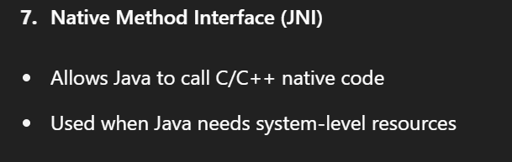

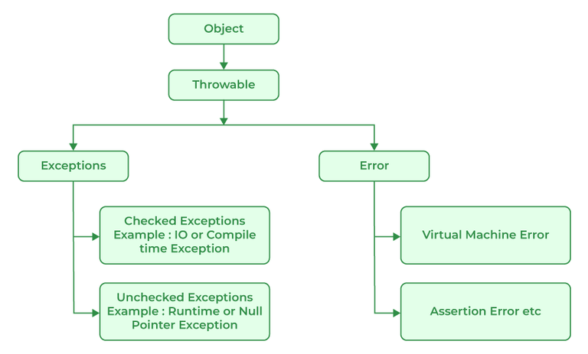

(VMError 🡪 StatckOverFlowError)

Checked Exception 🡪

ClassNotFoundException

NoSuchMothodException

SQLException

IOException

Unchecked Exception 🡪

ArithmeticException

NullPointerException

IndexOutOfBoundException (ArrayIndexOutOfBound, StringIndexOutOfBound)



